34.12: a)

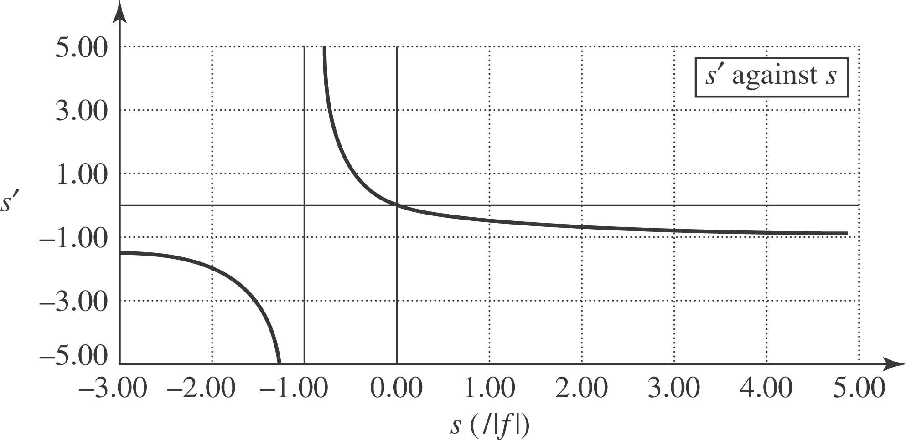
a) 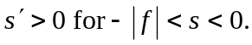
b) 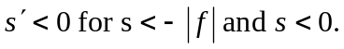
c) If the object is at infinity, the image is at the outward going focal point.
d) If the object is next to the mirror, then the image is also at the mirror. For the answers to (e), (f), (g), and (h), refer to the graph on the next page.
e) The image is erect (magnification greater than zero) for 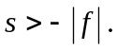
f) The image is inverted (magnification less than zero) for 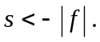
g) The image is larger than the object (magnification greater than one) for 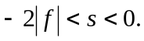
h) The image is smaller than the object (magnification less than one) for 